E-Commerce Product Catalog System: DFD and Sequence Diagrams
PHP and MySQL Mini Project

1. Overview
The product catalog lets a visitor browse products by category, search for products, and view product details and prices. No login is required. The system has three modules and two data stores.
Module | Purpose | Data store used
1.0 Browse categories | List categories and the products in a chosen category | D1 category, D2 product
2.0 Search products | Find products by keyword in name or description | D2 product
3.0 View product details | Show full details of one product | D2 product, D1 category

Data store | Table | Key columns
D1 | category | category_id, category_name
D2 | product | product_id, category_id, product_name, description, price, image, availability_status

2. Data Flow Diagrams

2.1 Level 0: Context diagram
The whole system is one process (0) that exchanges data with one external entity, the Visitor.
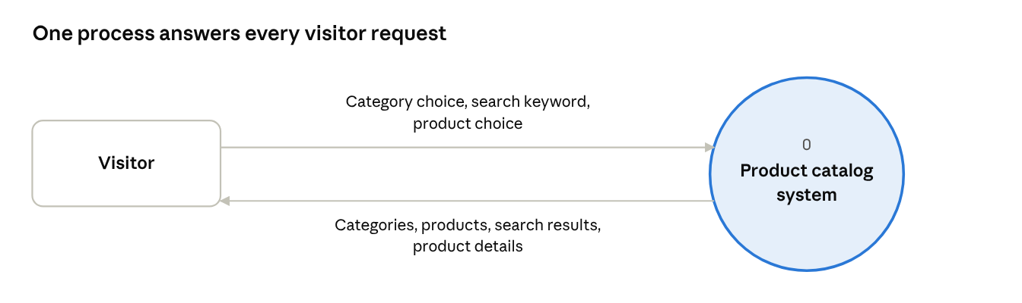
DFD level 0 · 1 process, 1 external entity
Flow | From | To
Category choice, search keyword, product choice | Visitor | Product catalog system
Categories, products, search results, product details | Product catalog system | Visitor

2.2 Level 1: Modules and data stores
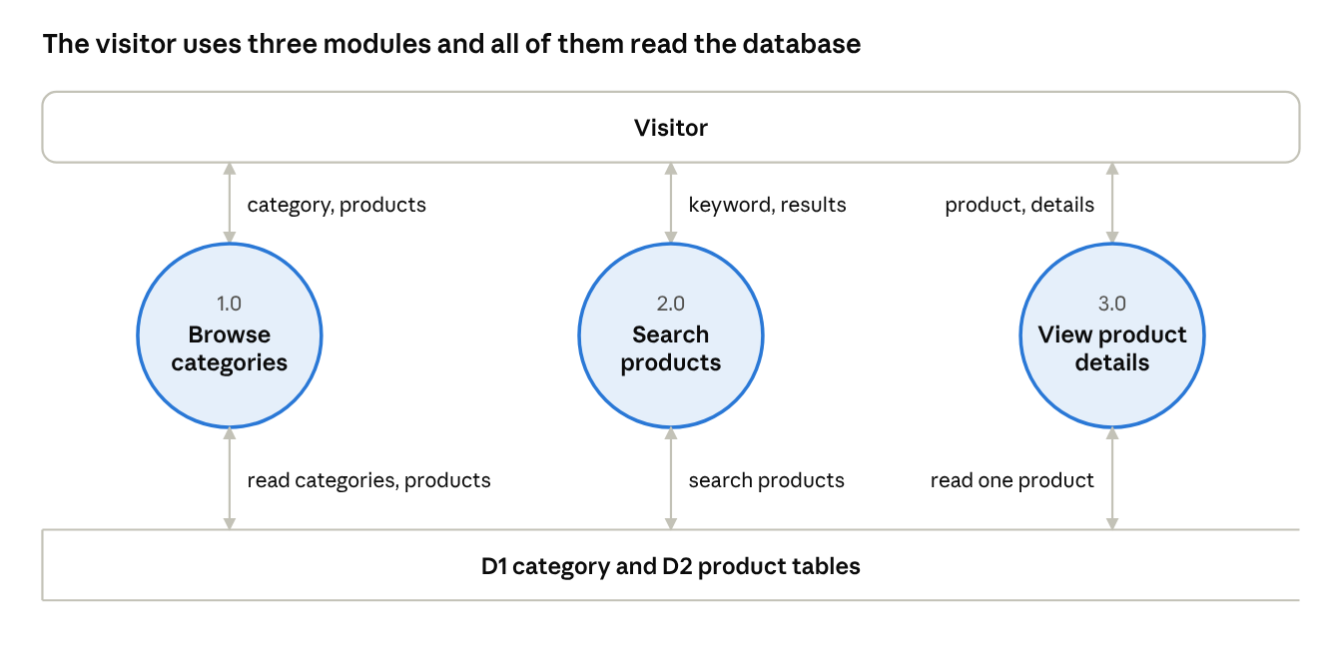
DFD level 1 · 3 processes, 2 data stores
Each module talks to the visitor and reads the database. The table below lists the exact flows.
Flow | From | To
Selected category | Visitor | 1.0 Browse categories
Categories, products | 1.0 Browse categories | Visitor
Read categories | 1.0 Browse categories | D1 category
Read products by category_id | 1.0 Browse categories | D2 product
Keyword | Visitor | 2.0 Search products
Query on name and description, matching rows | 2.0 Search products | D2 product
Search results | 2.0 Search products | Visitor
Selected product | Visitor | 3.0 View product details
Read product by product_id | 3.0 View product details | D2 product
Read category name | 3.0 View product details | D1 category
Product details | 3.0 View product details | Visitor

3. Sequence Diagrams
Participants in every diagram: Visitor, Browser, PHP script, MySQL.

3.1 Browse by category
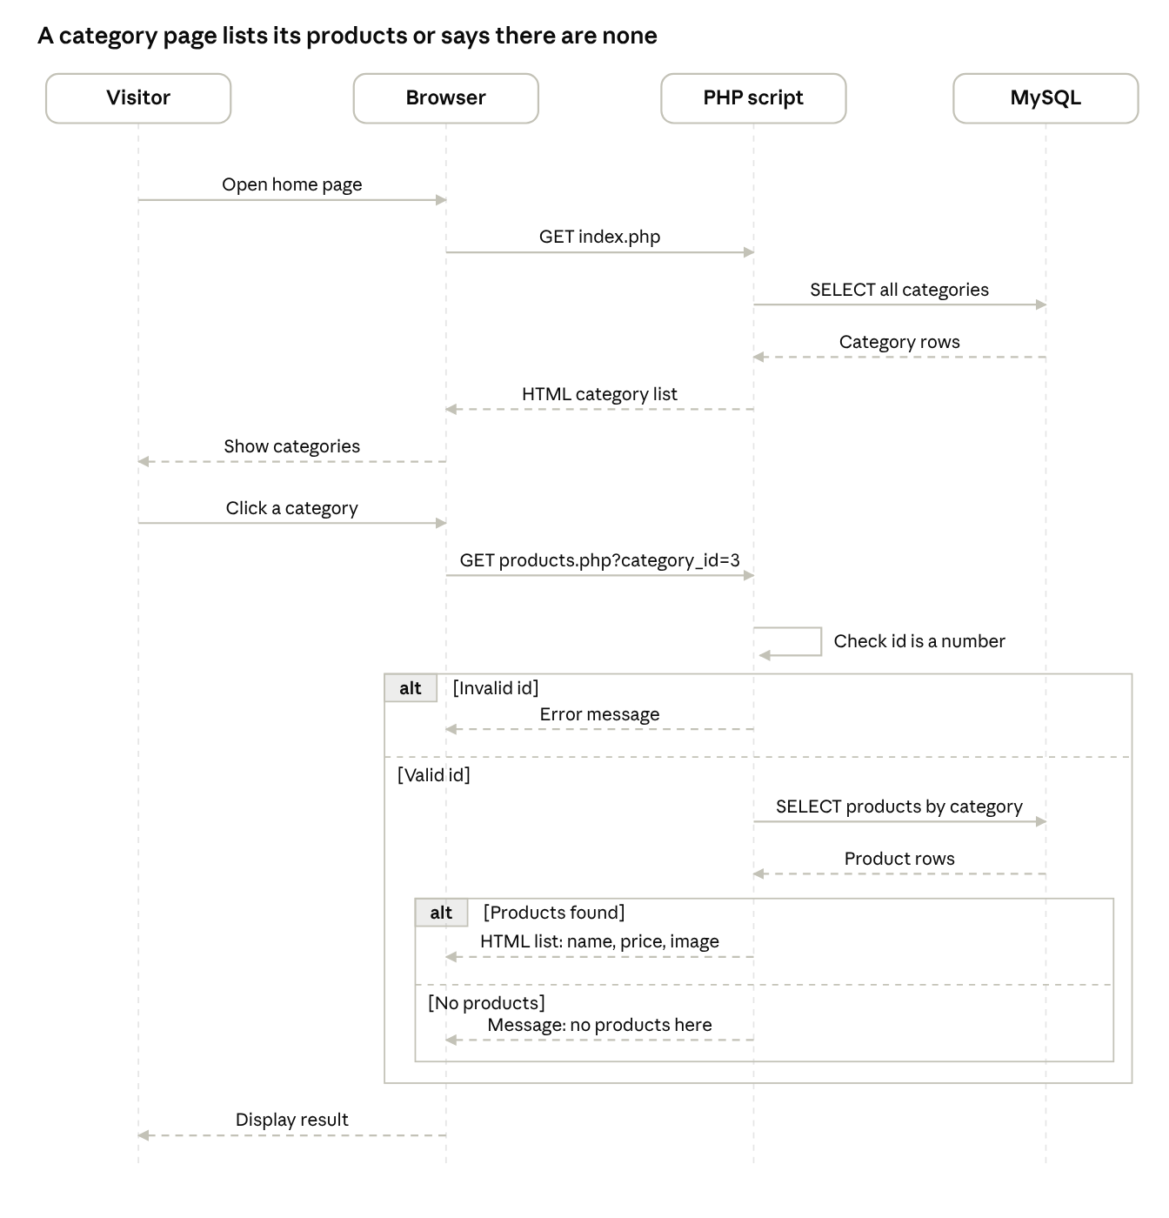
Sequence diagram · browse by category, 2 alternatives
- The visitor opens the home page and the browser requests index.php.
- The PHP script reads category_id and category_name from category and returns the category list.
- The visitor clicks a category and the browser requests products.php?category_id=3.
- The script checks that category_id is a number. If it is not, it returns an error message.
- The script queries product where category_id matches, using a prepared statement.
- If products are found, the script returns the list with name, price and image. If none are found, it returns a message saying the category has no products.

3.2 Search products
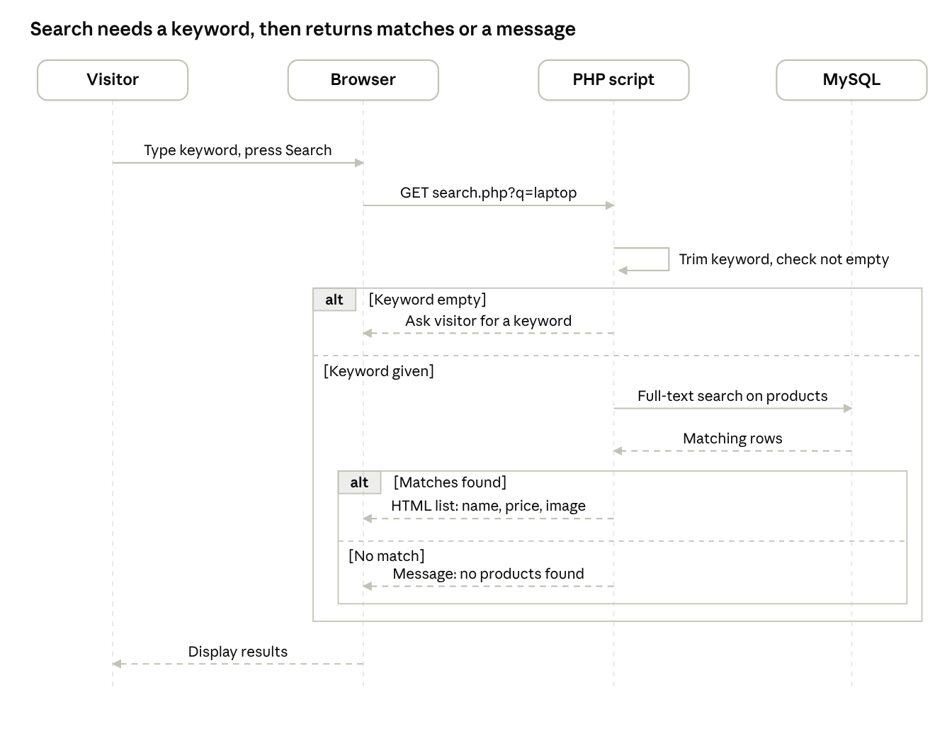
Sequence diagram · search products, 2 alternatives
- The visitor types a keyword and presses Search. The browser requests search.php?q=keyword.
- The script trims the keyword and checks it is not empty. If it is empty, it asks the visitor to enter a keyword.
- The script runs a full-text search on product_name and description using a prepared statement.
- If rows match, the script returns the results list with name, price and image. If not, it returns a message saying no products were found.

3.3 View product details
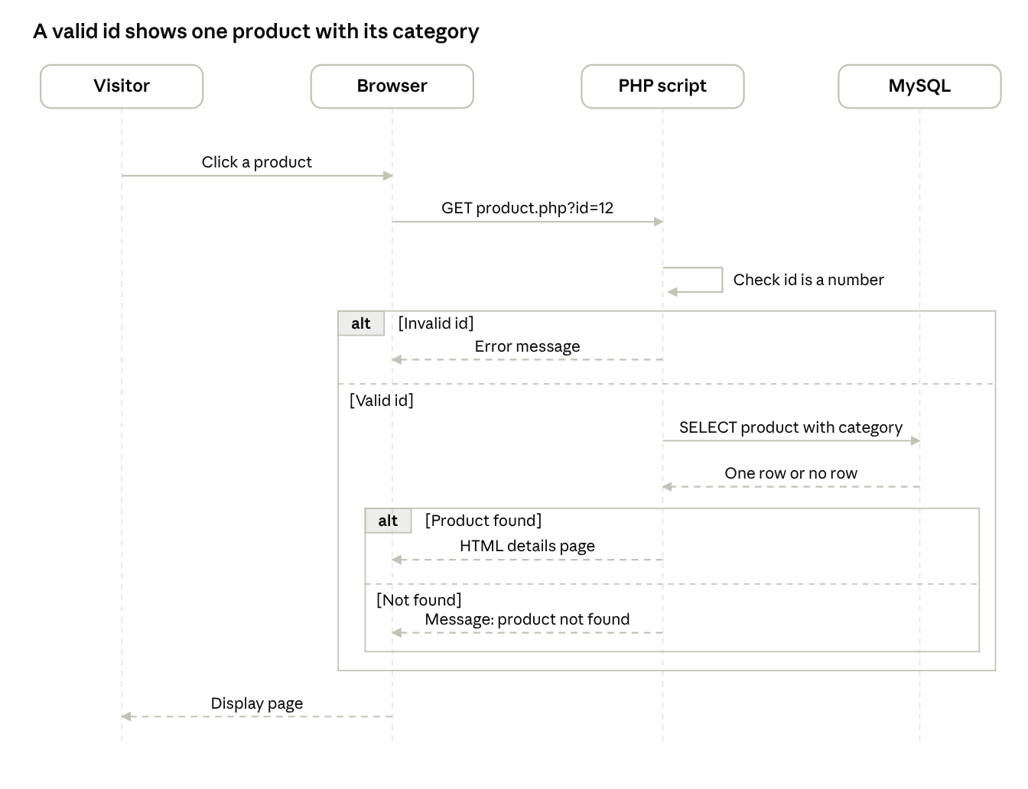
Sequence diagram · view product details, 2 alternatives
- The visitor clicks a product and the browser requests product.php?id=12.
- The script checks that the id is a number. If it is not, it returns an error message.
- The script reads the product joined with its category, using a prepared statement.
- If the product exists, the script returns name, description, price, image (or a placeholder), availability and category. If not, it returns a product not found message.

